Speaking of family life, the first thing that we will notice is marriage. How concerned are people with this? I think rings on fingers can answer you. So, we first pay attention to the percentage of married people in the different regions. As we can see, there are more people in West who choose to marry than those in Northeast.

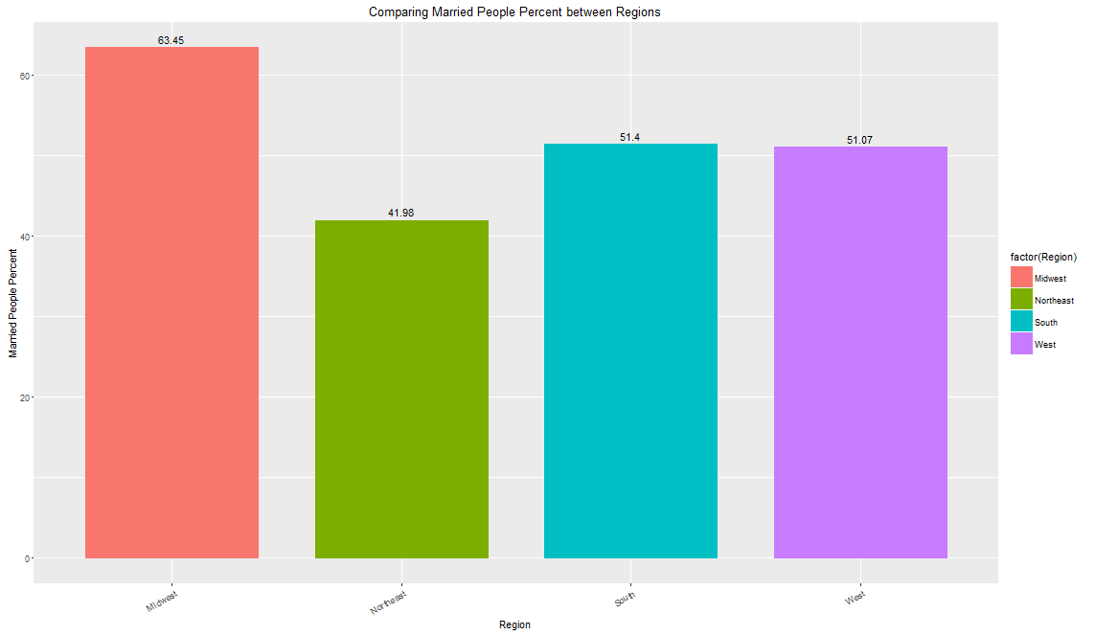

But, then there comes a new question. Does this phenomenon come from different age distribution in these regions?

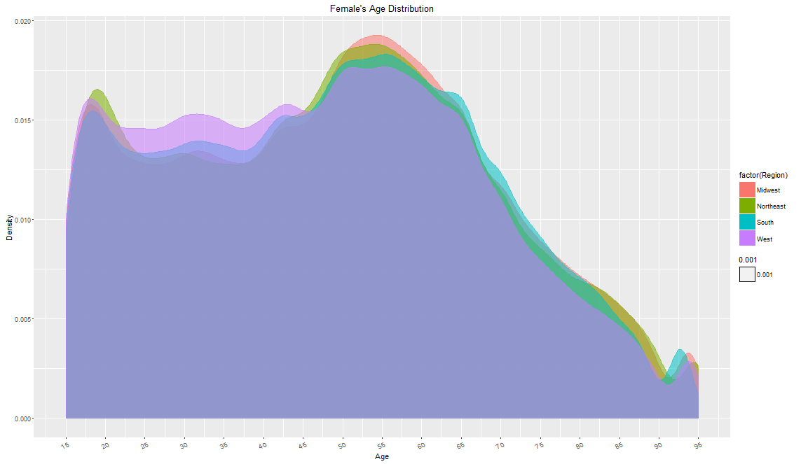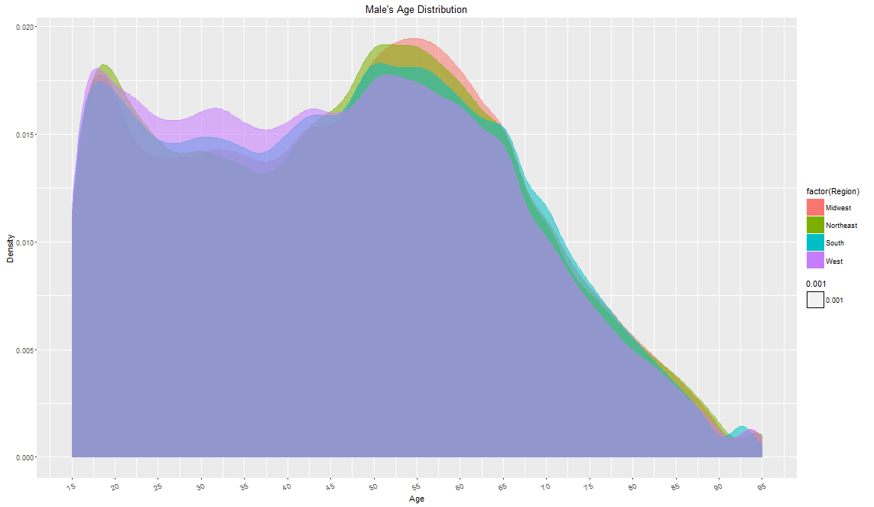

Then, we made these two density plots to show that there are actually more young people living in West than in Northeast. By common sense, we recognize that people are more willing to marry as their age grows. Maybe people realize that life is not but a span and two is better than one.

However, is this assumption true in realistic? In order to verify that, we build a logistic regression model and the significance testing shows that the relationship really exists.

And the percentage of people are really increasing as the age grows.

Coefficients:

Estimate Std. Error z value Pr(>|z|)

(Intercept) 3.3040822 0.0051250 644.7 <2e-16 \*\*\*

age -0.1017600 0.0001308 -778.1 <2e-16 \*\*\*

---

Signif. codes: 0 ‘\*\*\*’ 0.001 ‘\*\*’ 0.01 ‘\*’ 0.05 ‘.’ 0.1 ‘ ’ 1

(Dispersion parameter for binomial family taken to be 1)

Null deviance: 3125760 on 2582041 degrees of freedom

Residual deviance: 2047450 on 2582040 degrees of freedom

AIC: 2047454

Number of Fisher Scoring iterations: 5

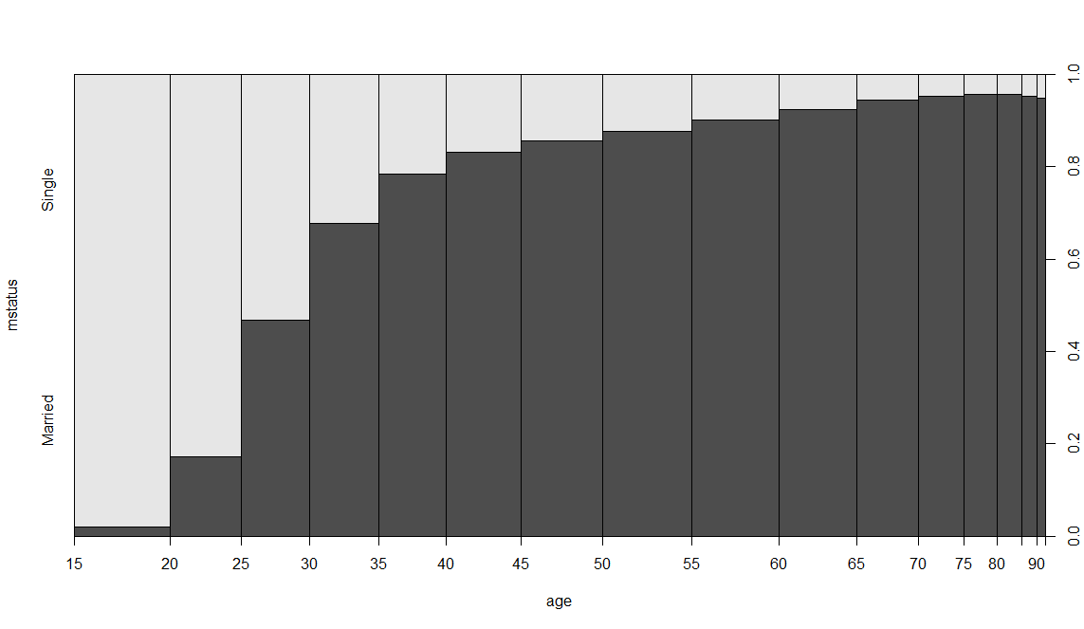

Due to the above analysis (diff. age dist and relations between age and marital status), we have to take age into account when we analyze marital status. These are the full version of marital status analysis between regions. The most interesting thing we found is that the percentage of single female in Northeast is higher than in West, though elder females in Northeast take up more percent of females, while the percentages of single males in these two regions are almost the same.

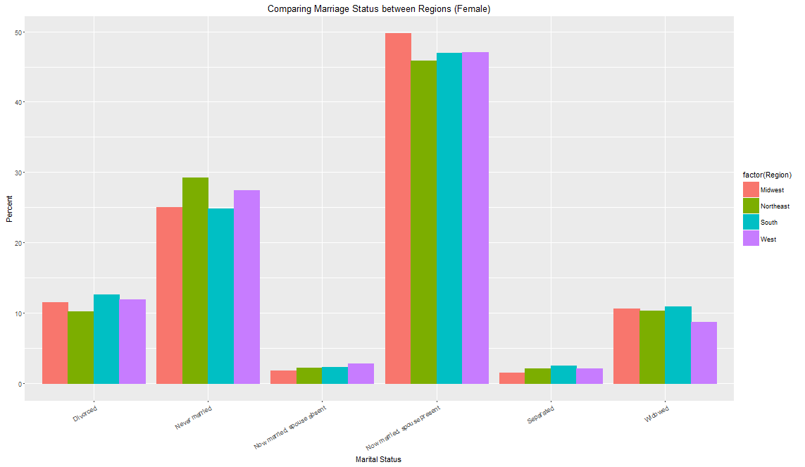

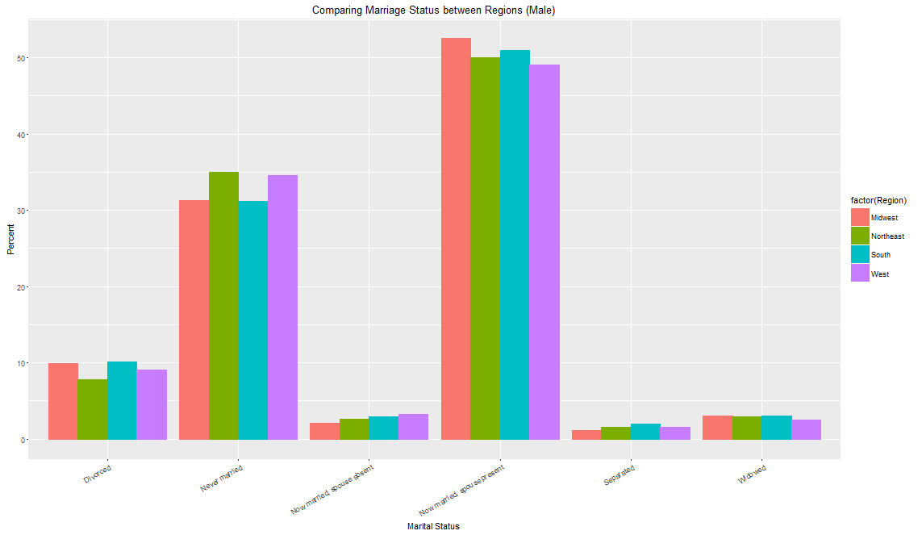

Also, we can see that single females in Northeast are likely to be elder than in West.?

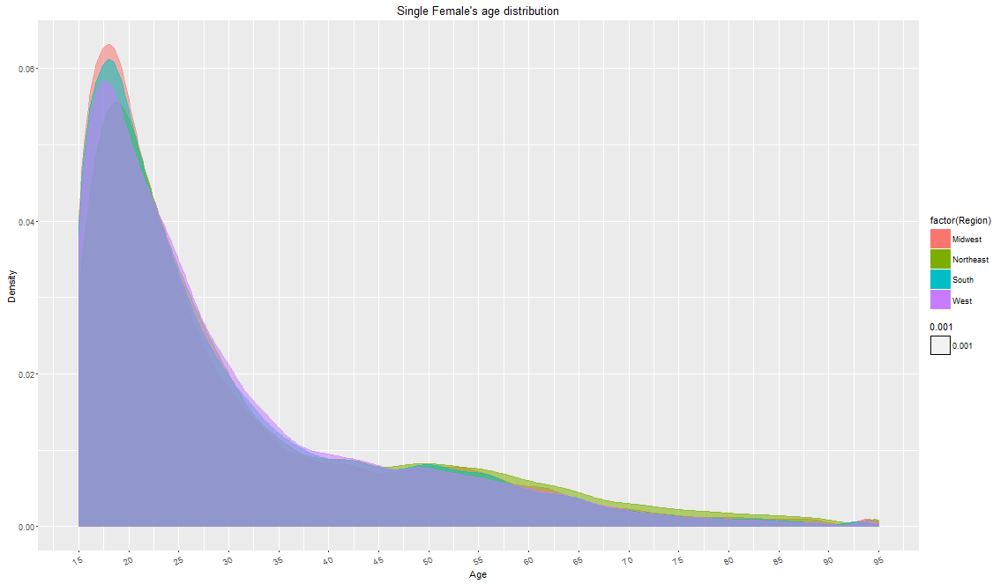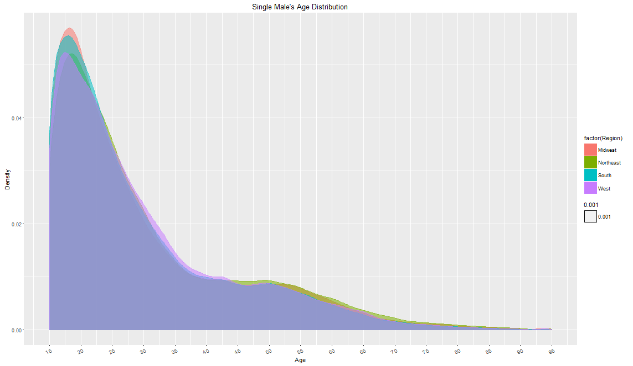

Besides, we found out that no matter females or males, more people living in Northeast than those in West chose to get married late in life.

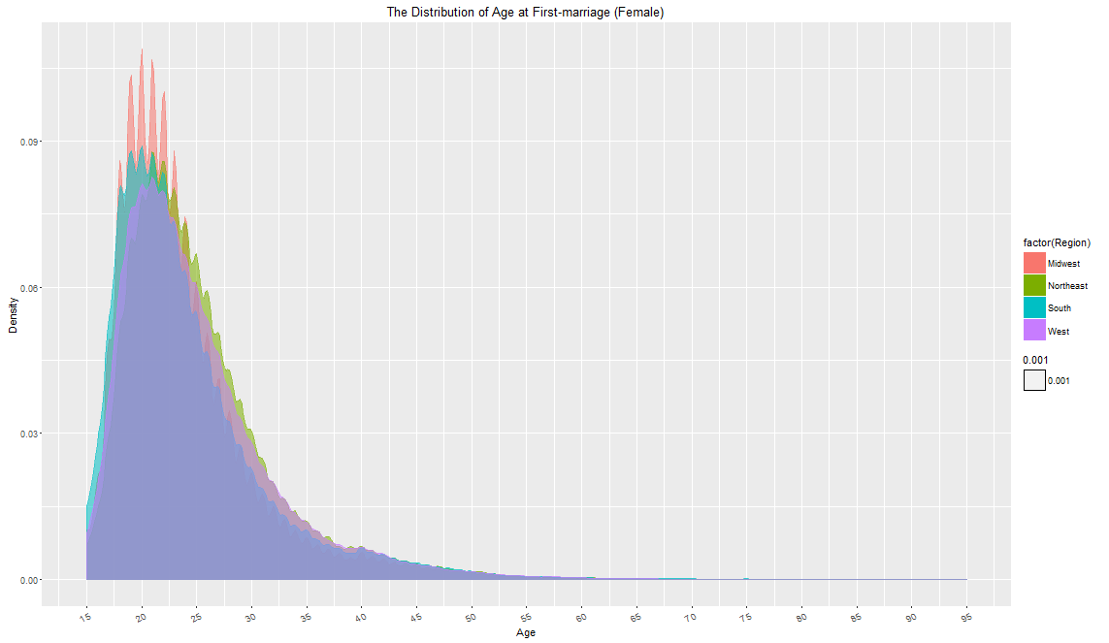

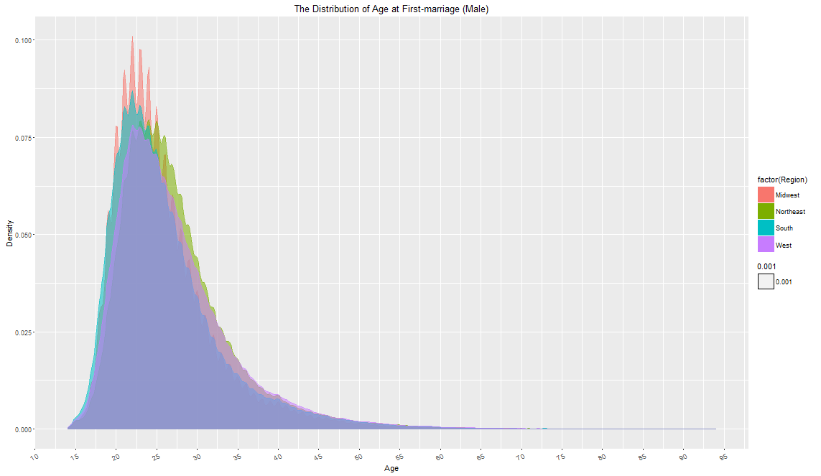

OK. You want to get married late. Let’s forget about the age.

How about the marriage stability? Actually, no matter females or males, people in West seems to have a higher probability to fail in their first marriage than those in Northeast. 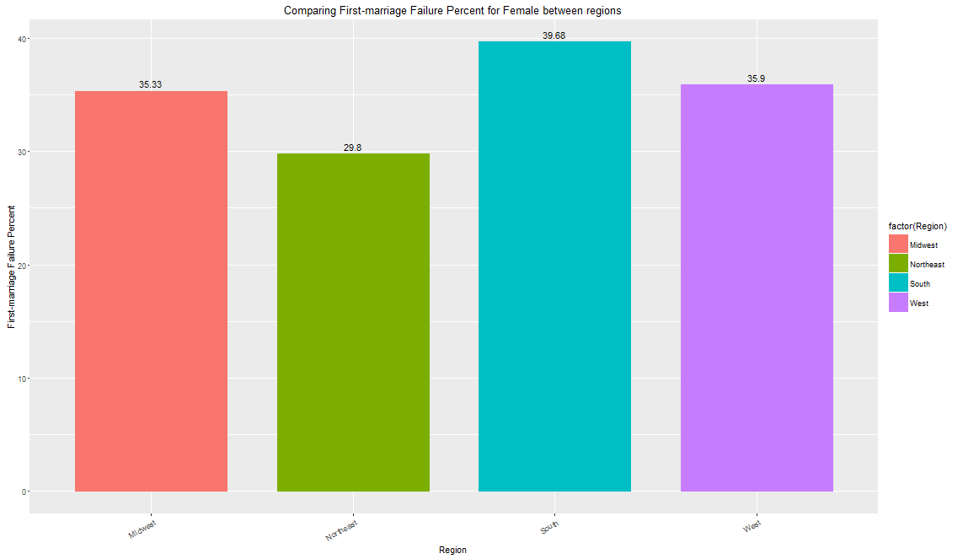

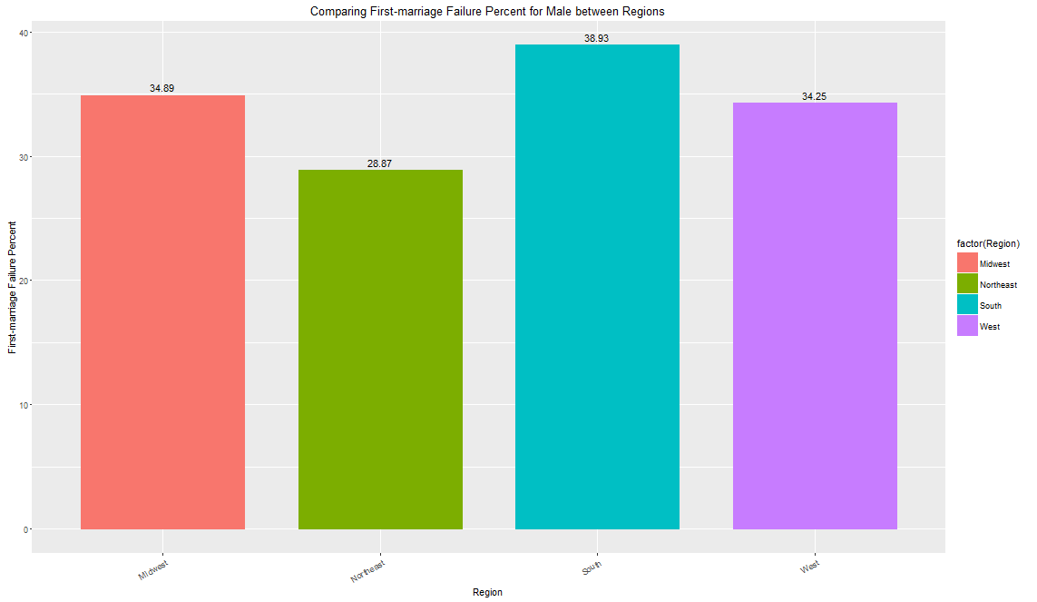

And people in West are also more likely to get married more than one time. To marry late seems to have an advantage at this respect.

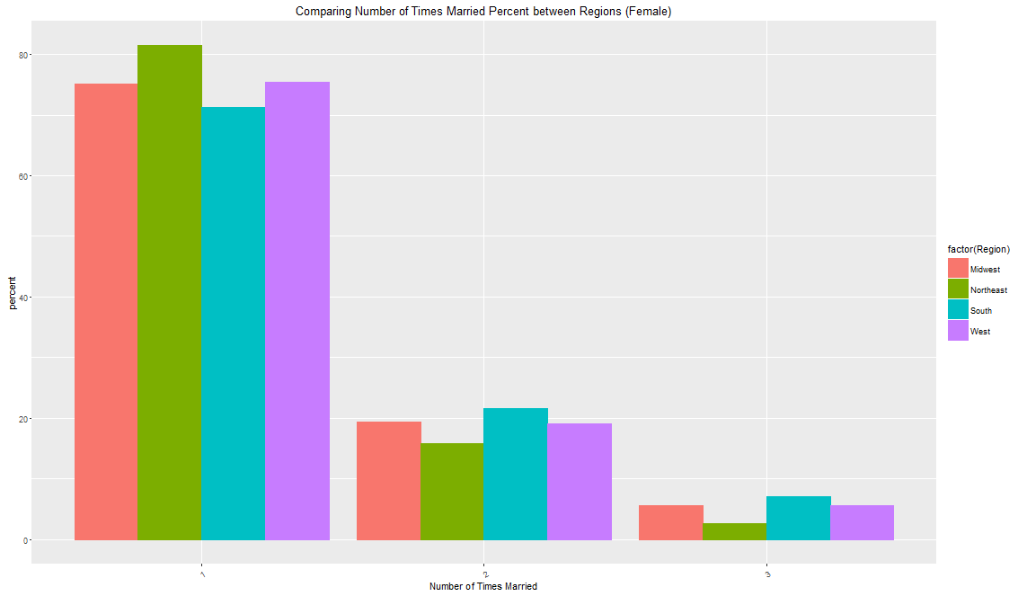

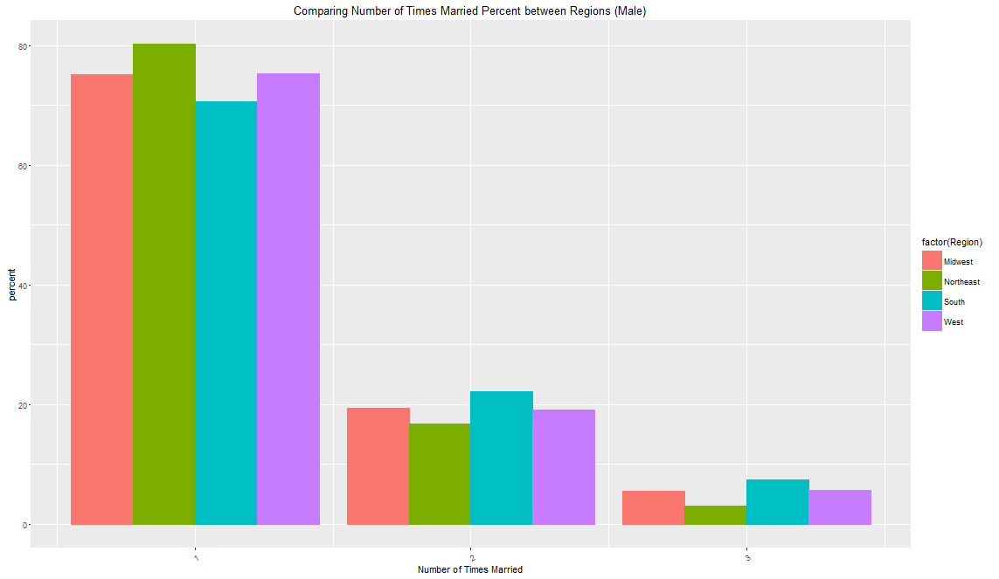

Now we focus a smaller group. What about same-sex marriage? It shows that Northeast has a higher percentage of same-sex marriage than. How does this happen? Is it related to the legalization pace of same-sex marriage? We expect to investigate further.

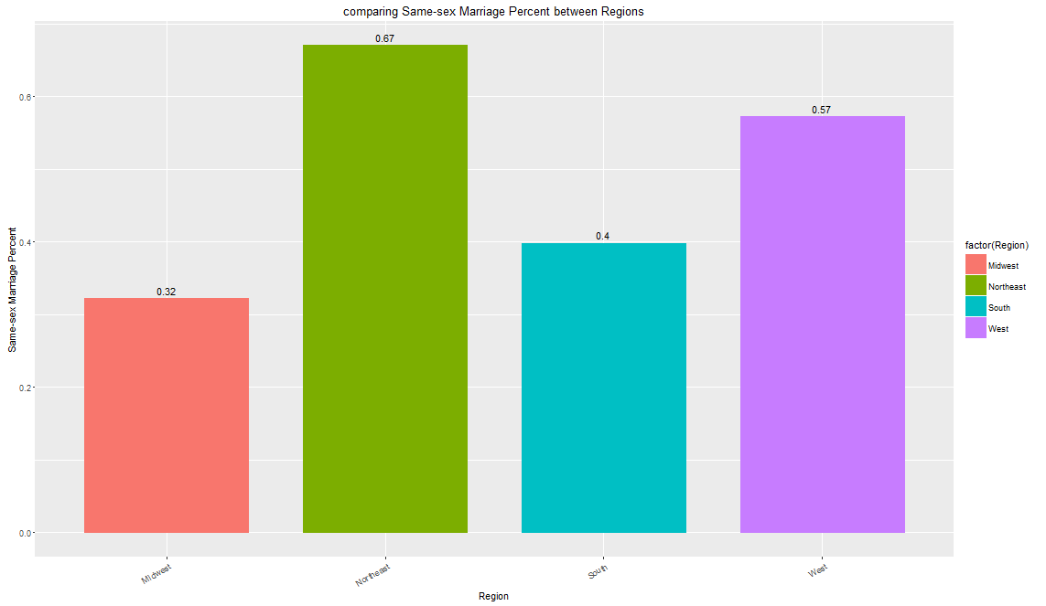

Children take an important role in family life. They are sometimes annoying. But they are super adorable and bring parents joy at most time. However, we don’t see significant difference between West and North east in terms of the percentage of parents.

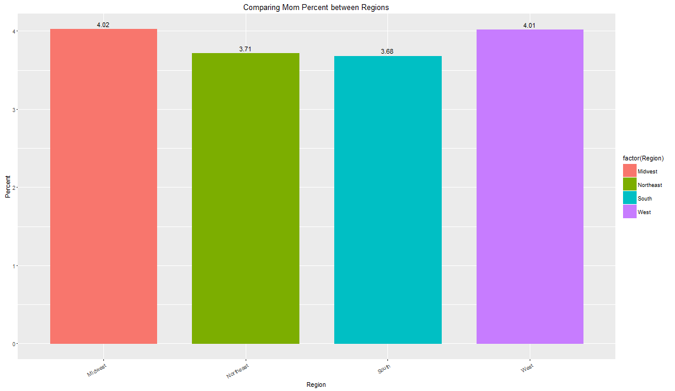

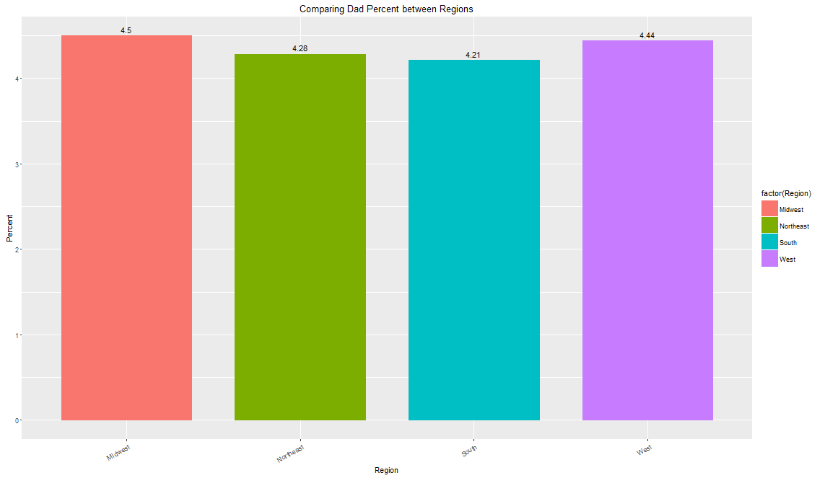

Then, we pay attention to a smaller group of people. It shows that more single people (never-married) in West chose to own a child than in Northeast. This difference is more significant in females.

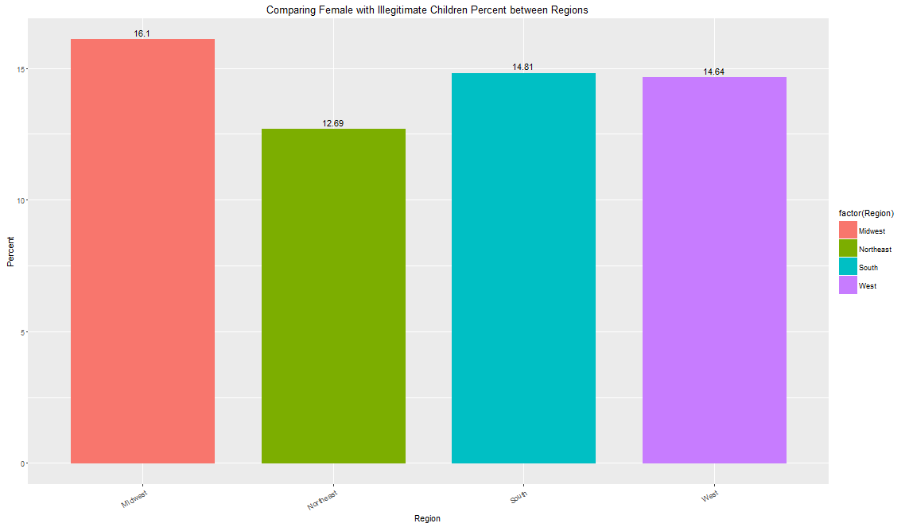

Also, more parent in West took care of their children without help of a spouse.

